**“Cities COVID Mitigation Mapping: Communications Guide”**

**Table of Contents**

How to use this Guidebook

C2M2 Background; Program Overview (Optional background language for your use)

Requested language for communicating about your C2M2 Project and the overall Program

Shared Reference Language

Messages for Twitter **I**  Facebook

A note on other social media

Website

Uploading your content to mapgive.state.gov/c2m2

Blogging for C2M2

[Qui](https://docs.google.com/presentation/d/1nib7AYnehyDgIRmAMD689bIdVj1l8Xc3/edit#slide=id.gafdfe16c26_0_0)[Bookmark](https://docs.google.com/document/d/1V_syPdCbg15_rjqNhapak2kq0wmLO7NxgHPMA8d2Ur4/edit#bookmark=id.mjwc487xt22u)[ck overview](https://docs.google.com/presentation/d/1nib7AYnehyDgIRmAMD689bIdVj1l8Xc3/edit#slide=id.gafdfe16c26_0_0)

Publicizing

Photos and Images

Tips and Tricks for Photographs

Licensing and Attribution

Alt-Text for Readers Who Are Blind or Have Low Sight

General MapGive Shareables: Flickr **I** YouTube

Social Media

Tips on Platforms

Accounts to follow and reference

Reference documents: [C2M2 Google Drive](https://drive.google.com/drive/folders/1-T2dxI0y3hhxb7brc4tGhlR9cR9oSEn1)

Additional Resources

Appendix

**How To Use This Communications Guide**

This guide is meant to provide C2M2 organizers, hub leads, and project partners with shared information about how to talk about, officially reference, and promote the Cities’ COVID Mitigation Mapping program.

**C2M2 Background**

Program overview information that is OPTIONAL for presentations

The COVID-19 pandemic has rapidly spread around the world affecting public health and having cascading impacts on nearly every aspect of human life. Challenges from COVID-19 extend far beyond the disease, to include disruption of the global economy and local socio-economic relationships.

The COVID-19 pandemic will continue to challenge vulnerable populations and communities long after the infection numbers peak. Many vulnerable populations around the world are experiencing a new complexity due to outcomes of the virus intensifying existing challenges such as poverty, food insecurity, obstacles to social, economic, and labor mobility, and access to education. Understanding these second-order impacts will help officials as well as civil society organizations mitigate negative effects and strengthen responses to address growing economic, health, and education needs.

Cities’ COVID Mitigation Mapping (C2M2) is a field-based program of the Office of the Geographer at the U.S. Department of State that builds partnerships to enhance geospatial capacity to use data and maps and help mitigate COVID-19 second order impacts in vulnerable communities. This program is supported by U.S. foreign assistance funding and is carried out in coordination with the U.S. State Department’s Office of Foreign Assistance and Bureau of Oceans and International Environmental and Scientific Affairs. It is facilitated by the American Association of Geographers (AAG) for project management.

The Cities’ COVID Mitigation Mapping program (C2M2) builds on global networks of geospatial experts to analyze second-order impacts of COVID-19. The goal of this program is to increase identification and understanding of the distribution and gaps in resources available to vulnerable populations in urban communities. This program has three regional hubs in Africa, Asia, and Latin America, where select local organizations, with regional geospatial and community development expertise, identify and work with local project partners to develop and guide C2M2 projects in each region. The hubs facilitate local projects’ application of participatory and remote mapping methods to create open data, conduct analyses, and produce publicly available digital maps.

**Shared Reference Language - Required⭐**

Please review the following shared language to describe the C2M2 program.

**✓** C2M2 Project Product Sourcing:

Source text to be included in all C2M2 Project Products:

***“Cities’ COVID Mitigation Mapping (C2M2) is a field-based program of the Office of the Geographer at the U.S. Department of State.”***

**✓**Acknowledgement:

Please use the following acknowledgement in any articles or written pieces: *The Cities' COVID Mitigation Mapping (C2M2) program is part of the MapGive Initiative in the Office of the Geographer at the U.S. Department of State that builds partnerships to enhance geospatial capacity, generate data, and share maps to support planning for mitigating COVID-19 second order impacts. We acknowledge the many partners who make this a successful program.*

**✓** Disclaimer:

Please use the following disclaimer: “*The views and opinions expressed in this article are those of the authors and do not necessarily reflect the official policy or position of any agency of the U.S. government. Assumptions made within the analysis are not a reflection of the position of any U.S. government entity.”*

**✓** Funding reference, if necessary:

*This work is supported by the U.S. Department of State.*

**✓** Logo guidance:

The C2M2 Projects are invited to use ***the MapGive Initiative C2M2 logo*** in Project-related briefings, banners, printed materials, and other communications to identify the partner as a C2M2 project member.

**Use of the State Department Seal is not allowed** by any C2M2 partner, unless approved in advance by the Department via the C2M2 Program Management Team.

Please feel free to ask the C2M2 management team about the use of the MapGive or State Department logo for specific circumstances.

**✓ Key talking points to be used in any C2M2 related presentation or interview:**

*Our project is one of 12 city-based projects, connected regionally and globally through the Cities’ COVID Mitigation Mapping (C2M2) program supported by the U.S. Department of State.*

*C2M2 is a program designed by the MapGive Initiative and the Office of the Geographer to expand global geospatial partnerships and capacity building to effect COVID-19 second order impacts in vulnerable communities. In each city, C2M2 project partners focus on key themes such as food security, the informal economy, tourism, health, and mobility to understand second-order impacts of COVID-19.*

*Each project is facilitated by one of three regional hubs, to build local capacity for using geospatial technologies, strengthen partnerships, and create new data and analysis to understand resource distribution and gaps. Projects generate data and analytic products to share openly within the community to support data-driven decision-making for economic and social needs (such as health, water, and education services).*

**✓** Key talking points to be used for any C2M2 related presentation

* **Overview.** The Office of the Geographer at the U.S. Department of State is expanding global geospatial partnerships and capacity building to mitigate COVID-19 second order impacts through the Cities’ COVID Mitigation Mapping (C2M2) program. The program has 12 city-based projects, which are facilitated by three regional hubs, to build local capacity for using open data and geospatial technologies, strengthening international partnerships, and creating new data and maps
* **Varied themes.** In each city, C2M2 project partners focus on key themes such as food security, the informal economy, tourism, health, and mobility to understand second-order impacts of COVID-19.*They generate open data and analytic products to support data-driven decision-making for economic and social needs(such as health, water, and education services).*
* **MapGive goals.** MapGive’s C2M2 program aims to increase understanding of the distribution and gaps in resources available to vulnerable populations in urban communities. This includes building partnerships to enhance geospatial capacity to use data and maps and help mitigate COVID-19 second order impacts in vulnerable communities. The hubs facilitate local projects’ application of participatory and remote mapping methods to create open data, conduct analyses, and produce publicly available digital maps.

**Sample Social Media Messages**

**Twitter**

What are second-order impacts of COVID-19? The Cities’ COVID Mitigation Mapping team has collected resources to help spread awareness: <https://mapgive.state.gov/c2m2/#resources>

The Cities’ COVID Mitigation Mapping program (C2M2) builds on global networks of geospatial experts to analyze second-order impacts of COVID-19: <https://mapgive.state.gov/c2m2/#home>

**Facebook**

Cities’ Covid Mitigation Mapping (C2M2) projects build local capacity to utilize open data and geospatial technologies, strengthen international partnerships, and create new data and analyses to inform data-driven decision making for planning to mitigate COVID-19 second-order impacts Cities’ Covid Mitigation Mapping (C2M2) project partners will focus on key themes: food security, informal economy, tourism, health, and mobility to address second-order impacts of COVID-19. The Cities’ COVID Mitigation Mapping program (C2M2) builds on global networks of geospatial experts to analyze second-order impacts of COVID-19. <https://mapgive.state.gov/c2m2/#home>

**Website**

Please direct all traffic to C2M2’s page on MapGive’s website: mapgive.state.gov/c2m2

Example: “For more information about the Cities’ COVID Mitigation Mapping (C2M2) program, please go to mapgive.state.gov/c2m2.”

C2M2 Latin America Hub page <https://mapgive.state.gov/c2m2/#asia-hub>

C2M2 Africa Hub page <https://mapgive.state.gov/c2m2/#latin-america-hub>

C2M2 Asia Hub page <https://mapgive.state.gov/c2m2/#africa-hub>

The C2M2 team, hubs, and projects will have educational and exciting material to post on the C2M2 website, which may include but is not limited to:

* Recorded webinars and workshops
* Explanatory videos of C2M2 projects
* Photo albums of teams at work, workshops, events, etc.

Each project’s specific page will have the option to add “Content Cards” on a rolling basis. If you would like to add a content card to a C2M2 project page, please email Erika Nunez at [nunezek@state.gov](mailto:nunezek@state.gov) for instructions. At a minimum, what’s needed will be a hyperlink to the content, a photo or descriptive image, and a short 1-2 sentence summary previewing the content to website visitors. It may take up to 2-3 business days before the item is posted.

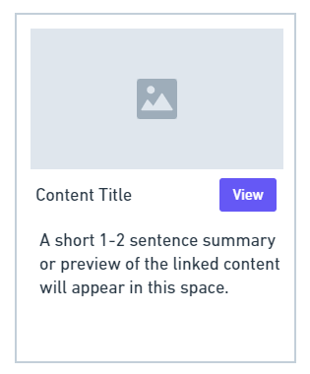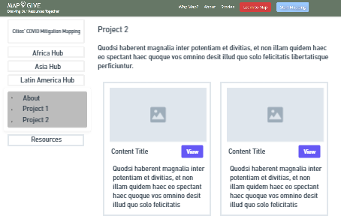

**Shareables: Photo and Video**

C2M2 hub leads and project partners are invited to post curated photo albums and videos on the MapGive flickr and youtube channels. This may be helpful if you would need a hyperlink a specific photo album or video to share on the MapGive website. If you have any questions, or would like to submit content to be approved, please contact [nunezek@state.gov](mailto:nunezek@state.gov) to get started.

**Flickr: MapGive**

<http://www.flickr.com/photos/mapgive>

**YouTube: MapGive**

http://www.youtube.com/mapgive

**Blogging for C2M2**

[**“C2M2 Quick Guidance: Blogs”**](https://docs.google.com/document/d/1DRXazwTzOzPB4zTbFkxsYu2SOwJao9lkq9PSE39Ope4/edit#heading=h.ismefn6sq588)

Please review the Shared Reference Language section as needed for blog publishing.

Requirement: 1 blog per quarter per hub

Important dates:

Q1: Oct 15 - Jan 15 (Extended)

Q2: Jan 16 - April 15 (Extended)

Q3: April 16 - July 15

Q4: July 15 - Oct 15

**Where to Host:** There is no strict requirement to host C2M2 related blog stories on a specific platform, and we encourage you to consider and choose the platform that best fits your objectives. This could include but is not limited to:

* Hub web presence
* C2M2 project partner web presence
* Author a MapGive story: Does require review in coordination with the DOS team, and additional State approval that may take 1-2 weeks. See examples of MapGive stories at https://mapgive.state.gov/stories/.
* AAG story
* Other web presence or blog

**\*Important note:** Before publication**,** please notify and share drafted blogs with the Erika Nunez [nunezek@state.gov](mailto:nunezek@state.gov), Laura Cline [clinelv@state.gov](mailto:clinelv@state.gov), and Melinda Laituri [Melinda.Laituri@ColoState.EDU](mailto:Melinda.Laituri@ColoState.EDU) .

When posting blogs on any platform, please do refer back to the mapgive.state.gov/c2m2 website and boilerplate language, as follows:

For more information about the Cities’ COVID Mitigation Mapping (C2M2) program, please go to mapgive.state.gov/c2m2.

**Frequency & Planning**

* Minimum 1 blog per quarter per hub required. To help in our planning, please submit your plan for at least three proposed topics and submission dates well before quarterly deadlines. (We know that topics can change sometimes and can accommodate revised plans later).
* More than one post per quarter is always welcome, and we can happily support.
* Timing: Please let us know if you would like to plan different topics during a specific week or ahead of an important date or event.

**Blog Post Types**

There are many styles of posting. We encourage you to explore the forms that work best with your other project responsibilities.

**Important Note:** When drafting blog posts, please keep in mind possible sensitivities of posting on the behalf of a U.S. Department of State funded program. Please reach out to Erika Nunez nunezek@state.gov to help clarify and answer any questions.

We have provided ideas for brief-form posts that do not replace the minimum requirement of one standard-length blog post per quarter but can help you capture your work quickly:

* **Standard posts** are recommended to be 300 - 800 words with an image or video clip
  + Example of a MapGive story <https://mapgive.state.gov/stories/ashgabat.html>
  + Example of a [MapGive story describing a workshop in Piura, Peru](https://mapgive.state.gov/stories/piura-workshop.html)
* **Multiple-hub**, **collaborative posts** are sometimes valuable, although hard to manage because of all of the specific information from different locales. It helps if there is a specific shared topic, such as how different hubs are approaching questions of public health data. These might be longer than 800 words if necessary.
* **Perspectives** are personal reflections on the nature of the work or the community you are working with. It could also include challenges your team faced in your work. It should be accompanied by a headshot, either casual or formal (casual is probably best, preferably in an appropriate setting). There is no set word count for these. They can be very short (a brief post - a photo and quote) or longer (a standard post - an essay or interview).
* **Q&A:** these are perspective pieces, but in conversation form. Let us know if you’d like suggestions for questions to ask.
* **Brief posts** can include (these are ideas, feel free to ask us about variations)
  + **Data Glance** - a compelling graphic plus a few sentence or a paragraph maximum on some interesting insight or discovery
  + **Candid from an event** - A photo of people at work or otherwise gathered at one of your events, with a brief who-what-why and a quote from a participant. Roughly a paragraph or two at most.
  + **Candid from your location** - You can capture (or ask your community members) to grab an Instagram-style moment near where you are working, with a quote on its significance to the work. (Do stay aware of privacy issues and only photograph public places, with no close-up photos of people without permissions.)

**Suggested Topics**

As you choose your topic and approach, think about your intended audience (“I am writing primarily for peers in the mapping community,” or “I would like to attract other college students to the practice of mapping.”)

**C2M2’s audiences are as follows:**

* C2M2 network of hubs and project teams (We are our own best, first audience!)
* Open mapping community, especially the humanitarian and development focused mappers who might want to engage with C2M2, either for our projects or their own (while considering different sensitivities of state-based versus NGO or academically based partners).
* Public - college-bound and college students, teachers at all levels, academics, public officials at the local and regional levels, press who may be able to amplify

**C2M2 activities and themes**

* + COVID-19’s second-order impacts, especially the focus areas of hubs and projects (e.g. education, migration, etc)
  + The role of open mapping in supporting civil society
  + Highlighting the role of college students in open mapping
  + The practice of open mapping in disaster planning, can look at many aspects of the issue, from the participatory approaches of the projects, to lessons learned and ethical issues, to practical approaches.
* We also encourage integrating these themes and ideas from AAG
  + Foreground the work of geographers and the local knowledge of residents and mapping participants.
  + Geoethics, especially data sovereignty and ownership;
  + Interplay of C19 with climate change and human rights/needs

**Additional Guidance for Hub Leads**

* Hub leads have responsibility for ensuring that the minimum blog requirement is met, but have flexibility in the approach they take to make it happen (e.g., they can assign a staff member).
* Advise to check in at least monthly at the bimonthly C2M2 hub lead meetings or with Erika Nunez [nunezek@state.gov](mailto:nunezek@state.gov) on the status of your blog post(s)
* Consider asking or encouraging your project teams to provide input and suggestions on topics and timing
* For one time in the program cycle, hub leads can collaborate on a co-authored piece which meets each hubs’ blog requirement

**Language**

* There isn’t a strict English-only requirement.
* *MapGive stories would need, at least, a version translated in English (MapGive team can work on those translations, the story can be published in multiple language versions)

**Blog Writing Tips**

The following checklist can assist in reviewing your blog drafts:

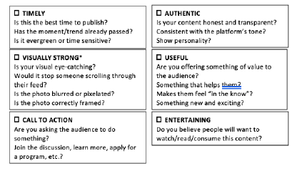

If you selected all 6, that’s ideal content!

If you selected 5/6, your content is good

If you selected 4/6, you content is acceptable, but it might need some work

If you selected 3/6, the content might not be ready for publishing. Regroup to improve or coordinate with the regional hub or C2M2 team.

Examples

<http://blog.kathmandulivinglabs.org/>

<https://www.youthmappers.org/blog>

**Photos and Images**

Most blog posts need at least one image to accompany the text. Some topics will require additional images. When choosing a blog platform, try out how it handles different kinds of photos -- a header photo, an image in the text, and so forth. Ideally, you want to work with a blog platform that can accommodate photos of varied quality and sizes, and that intuitively resizes your photos for you.The platform should also be mobile-sensitive, meaning that it looks as good on mobile phones and pads as it does on laptops.

**Tips and Tricks for Photographs**

Photographs should usually include people in action. If you feature group or single portraits or headshots, and you have the ability to take them yourself or make requests, find out if you can get photos against interesting backgrounds. Outdoor photos are often best.

When photographing specific people for publication, check their name, title, and pronouns so you can write a correct caption.

When you plan to photograph an event or meeting, build a simple permission notice into your registration or sign-in process on site. Notify participants that you plan to document the event with photography and/or videography, and ask them to sign an acknowledgement.

**When photographing people in public spaces (crowd shots and “atmosphere,”), make sure you are familiar with your country’s laws and practices about permissions.** In the United States and many other countries, it is legal to photograph other people in public places without permission, as long as you are not deliberately violating their privacy in other ways (e.g., photographing one person in a compromising situation). The best approach to such photos is to shoot from a distance, focus on the place instead of any one person, and -- when it is possible -- ask permission first. Here are some tips both for visual interest and for creating a bit more privacy for people you photograph in public:

* Think about interesting angles. Photographing a plaza or street from above can be more dynamic than a crowd shot at ground level. Photographing many feet walking on pavement can be an effective way to talk about streets, commerce, and day to day living.
* Think symbolically and iconically. What is your city known for? What is it known for locally but less well-known for globally? Choose places and objects that help tell a story.
* Contrast sharp focus in the foreground with blur in the background. Are you writing about transport? Photograph a bus sign or bicycle in the foreground, and slightly blur the people going past in the background to make for exciting contrast.

**Licensing and Attributions**

When doing image searches, always make sure you understand what license an image is under. You can search Flickr, Unsplash, Pixels, and Public Domain Photo for free-with-attribution images (on Flickr, pull down the “Any License” menu and specify Commercial Use Allowed), meaning that you should include attribution any time you use them, but they are otherwise free and available. [Creative Commons](https://creativecommons.org/) is another source for images.

Often, historic images are in the public domain and can add interesting texture to a post. You usually also need a related contemporary image.

Maps and location visualizations will obviously be a big part of many of your posts. Make sure to fully thank the team members who contributed.

Most of the time, an image will be more useful to a blog when it is horizontal (wider than it is tall) instead of vertical, although both can be made to work. In general, resolution of 300 dpi is advised, although many blogging platforms can compensate for photos with less high resolution.

Choose images with high contrast and clarity of image when you can, not too much happening all at once. You want your image to make a bold impression, and for some images (infographics, maps, charts), you also want it to make a point.

**Alt-Text for Readers who are Blind or Have Low Sight**

For every image you use -- on the blog and on social media -- you should use the “alt-text” option to provide a description for people who are blind or have low sight. If using alt-text is confusing, you can just include the description in your caption for the image. Your description does not need to be elaborate, just include the information a reader needs. [Here are tips for best practices in labeling description](https://accessibility.huit.harvard.edu/describe-content-images) (we also modeled it in the alt-text and caption below)

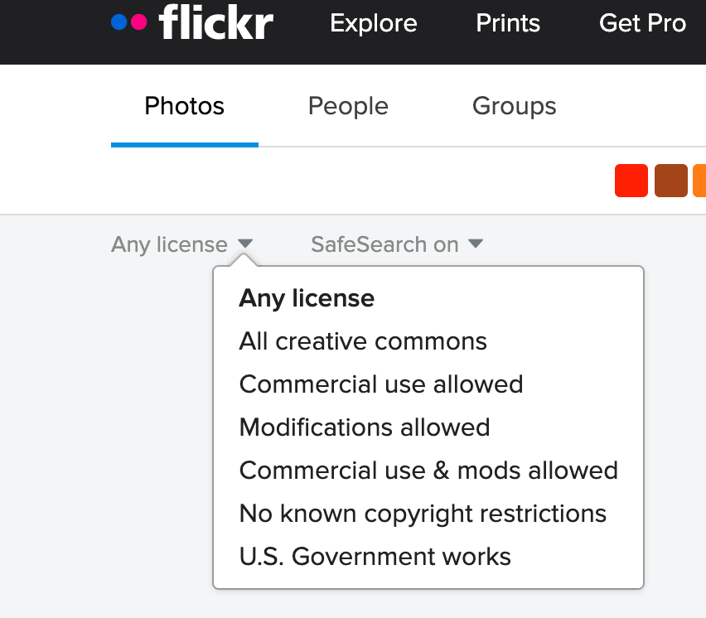

Screenshot from Flickr showing the menu choices for photo permissions, starting with “Any license” and providing 7 different choices for different types of use.

**Accounts to Follow and Reference**

Please review and update as needed.

@MapGive

|  |  |  |  |  |  |  |  |  |
| --- | --- | --- | --- | --- | --- | --- | --- | --- |
| **Organization** | **City** | **Country** | **Website** | **Twitter** | **Facebook** | **Instagram** | **Other** | **Local Embassy Twitter** |
| UASG Advisors |  |  | <https://www.facebook.com/uasgadvisors/> |  | <https://www.facebook.com/uasgadvisors/> | N/A | <https://www.linkedin.com/company/uasg-advisors/> | <https://twitter.com/usembyaounde?lang=en> |
| Catholic University of Mozambique in Pemba | Pemba, MZ | MZ | <http://www.ucm.ac.mz/> | <https://twitter.com/ucm_online?lang=en> | N/A | N/A | Not active on Social media | <https://twitter.com/usembassymaputo?lang=en> |
| Provincial Directorate of Health, Women and Social Action | Pemba, MZ | Mozambique | <https://www.pmaputo.gov.mz/por/Informacao/Informacoes-por-Sector/Direccao-Provincial-do-Genero-Crianca-e-Accao-Social> | N/A | <https://www.facebook.com/Minist%C3%A9rio-do-G%C3%A9nero-Crian%C3%A7a-e-Ac%C3%A7%C3%A3o-Social-266849430393189/> | N/A |  | <https://twitter.com/usembassymaputo?lang=en> |
| Department of the Provincial Directorate of Economy and Finance | Pemba, MZ | Mozambique | <https://www.mef.gov.mz/> | N/A | N/A | N/A |  | <https://twitter.com/usembassymaputo?lang=en> |
| Mozambique’s Eduardo Mondlane University | Maputo, MZ | Mozambique | <https://www.uem.mz/> | <https://twitter.com/uemmoz?lang=en> | <https://www.facebook.com/uemmoc/> | N/A |  |  |
| GroundTruth Initiative | Washingon, DC, USA | USA | <http://groundtruth.in/> | N/A | N/A | N/A |  | <https://twitter.com/USEmbassyKenya> |
| Map Kibera Trust | Kibera, Nairobi, KE | Kenya | <https://mapkibera.org/> | <https://twitter.com/mapkibera?lang=en> | <https://www.facebook.com/MapKibera> | <https://www.instagram.com/map_kibera/?hl=en> |  | <https://twitter.com/USEmbassyKenya> |
| Strathmore University | Nairobi, KE | Kenya | <https://www.strathmore.edu/> | <https://twitter.com/StrathU> | <https://www.facebook.com/StrathmoreUniversity> | <https://www.instagram.com/strathmore.university/> |  | <https://twitter.com/USEmbassyKenya> |
| EACHRights | Nairobi, KE | Kenya | <https://eachrights.or.ke/> | <https://twitter.com/EACHRights> | <https://www.facebook.com/EACHRights/> | N/A |  | <https://twitter.com/USEmbassyKenya> |
| Université Officielle de Bukavu (UOB), Faculty of Sciences | Bukavu, DR | Democratic Republic of the Congo | <https://www.univofbukavu.org/> | N/A | <https://www.facebook.com/Universit%C3%A9-Officielle-de-Bukavu-249194778465791/> | N/A |  | <https://twitter.com/USEmbKinshasa> |
| Centre d’appui à la promotion de la santé (CPSA) | Ibanda, DR | Democratic Republic of the Congo | <http://www.anps-prevention-sante.fr/presentation-cpsa/> | N/A | N/A | N/A |  | <https://twitter.com/USEmbKinshasa> |
| Local healthcare official (DPS) | Bukavu, DR | Democratic Republic of the Congo |  |  |  |  | Can't find a specific website for this | <https://twitter.com/USEmbKinshasa> |
| National Institute of Statistic | Ibanda, DR | Democratic Republic of the Congo | <http://ins.mkbco.pro/> | N/A | N/A | N/A | Very difficult to find social media | <https://twitter.com/USEmbKinshasa> |
| City of Bukavu | Bukavu, DR | Democratic Republic of the Congo | <http://mairiedebukavu.net/> | <https://twitter.com/bukavuville> | <https://www.facebook.com/Mairie-de-la-ville-de-Bukavu-261225787369283/about/> | N/A | Inactive | <https://twitter.com/USEmbKinshasa> |
| Kathmandu Living Labs | Kathmandu, NP | Nepal | <http://www.kathmandulivinglabs.org> | <https://twitter.com/ktmlivinglabs> | <https://www.facebook.com/kathmandulivinglabs> | <https://www.instagram.com/ktmlivinglabs/> |  | <https://twitter.com/usembassynepal> |
| Public Lab Mongolia | Ulaanbaatar, MN | Mongolia | <https://www.publiclabmongolia.org/> | <https://twitter.com/mon_public> | <https://www.facebook.com/publiclabmongoliango/> | N/A |  | <https://twitter.com/mglembassy_usa?lang=en> |
| Bangladesh Open Innovation Lab | Dhaka, BD | Bangladesh | <https://boiledbhoot.org/> | <https://twitter.com/boiledbhoot> | <https://www.facebook.com/BoiledBhoot> | N/A |  | <https://twitter.com/usembassydhaka> |
| Universidad San Francisco de Quito | Quito, EC | Ecuador | <https://www.usfq.edu.ec/en> | <https://twitter.com/USFQ_Ecuador> | <https://www.facebook.com/USFQEcuador/> | <https://www.instagram.com/usfq/> |  | <https://twitter.com/usembassyec?lang=en> |
| Universidad Catolica de Chile | Santiago de Chile, CL | Chile | <https://www.uc.cl/> | <https://twitter.com/ucatolica?lang=en> | <https://www.facebook.com/ucatolica/> | [instagram.com/ucatolicaoficial/](http://instagram.com/ucatolicaoficial/) |  | <https://twitter.com/embajadaeeuucl?lang=en> |
| Universidad Peruana Cayetano Heredia | Lima, PE | Peru | <https://www.cayetano.edu.pe/cayetano/es/> | <https://twitter.com/CayetanoHeredia> | <https://www.facebook.com/Cayetano.Oficial/> | N/A |  | <https://twitter.com/usembassyperu?lang=en> |
| EcoCity Builders | Cusco, PE | Peru | <https://ecocitybuilders.org> | <https://twitter.com/EcocityBuilder> | <https://www.facebook.com/ecocitybuilders> | <https://www.instagram.com/ecocitybuilders/> |  | <https://twitter.com/peruintheusa?lang=en> |
| Universidade Federal de Minais Gerais | Belo Horizonte, BZ | Brazil | <https://ufmg.br/> | <https://twitter.com/ufmg> | <https://www.facebook.com/ufmgbr> | <https://www.instagram.com/ufmg/> |  | <https://twitter.com/embaixadaeua?lang=en> |

**Additional Resources**

**C2M2 Resource hub: https://mapgive.state.gov/c2m2/#resources**

**Appendix**

**The MapGive initiative has a list of pre-approved subject matter** as part of blanket authorization for HIU social media accounts will include the following (all content will conform to content rules outline in 3 FAM 4175.2):

* Systematically retweet appropriate content from our core colleagues, i.e. OFDA, YouthMappers, Secondary Cities, Humanitarian OpenStreetMap Team, American Red Cross, Missing Maps, and World Bank GFDRR.
* Relevant information from Re-tweeting content individuals, including from key influences and community leaders
* Tweet news and blog posts relevant to the humanitarian mapping community.
* Tweet news of significant events/milestones, i.e. the National and International State of the Map OpenStreetMap conferences and other key messages on important dates such as World AIDS Day.
* Tweet out announcements and RSVP links for Mapathons occurring throughout the humanitarian mapping community
* Tweets information in support of and encouraging mapping in Universities and Schools
* Tweets encouraging information in support of mapping in response to natural disasters
* Tweets encouraging general mapping and validation
* Tweets encouraging mapping towards targeted mapping campaigns
* Tweet out metrics related to MapGive projects and user contributions
* Tweet out tips or Information on instructional mapping related guides
* Tweet out messages acknowledging volunteers supporting the MapGive initiative
* Tweet new job/internship openings as they become available.
* Tweet out Imagery to the Crowd success stories
* Tweet out photos of mapping related activities
* Tweet out HIU infographics designed to grow and motivate an audience of volunteer mappers
* Tweet out text-based messages designed to grow and motivate an audience of volunteer mappers
* Tweet out information on relevant events, presentations, or activities attended by or associated with GGI/HIU MapGive staff
* Tweet out updates to the MapGive website and other websites where GGI/HIU MapGive staff have contributed.
* Tweet out congratulatory tweets to core colleagues and partners on key accomplishments.
* Information on engagement with audiences, including replying to comments and questions via social media
* Information on engagement with audiences from GGI/HIU MapGive staff via other social media platforms and tools such as Facebook groups.